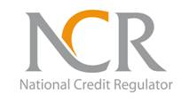

NCR336/10/2015

REQUEST FOR PROPOSAL FOR THE PROVISION OF INSURANCE BROKERAGE SERVICES FOR THE NCR

SUBMISSION REGISTER: CLOSED ON 03/12/2015

NO | PROVIDER'S NAME
1 | MMELA FINANCIAL SERVICES
2 | AFRICAN DWAN RISK SOLUTIONS
3 | AFN FINANCIAL SERVICES
4 | BATHATHU RISK SERVICES
5 | INDWE RISK SERVICES
6 | SANKOFA INSURANCE BROKERS
7 | KUNENE MAKOPO RISK SOLUTIONS
8 | MARSH
9 | LATERAL UNISON
10 | GIB INSURANCE BROKER
11 | AON PRETORIA
12 | INSURANCE ZONE

